Andrea Montgomery, PhD
Associate Professor of Music and Music Education
amontgomery@tougaloo.edu
601.977.7744|601.977.7757

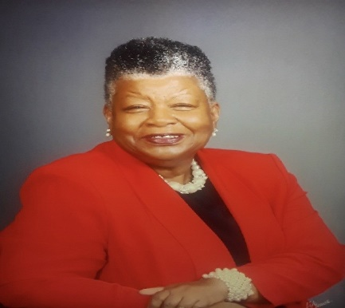

Dr. Andrea Montgomery is a committed educator with a deep passion for advancing music education. She currently serves as Associate Professor of Music and Music Education at Tougaloo College where she teaches courses in Music History, Music Literature; Music in Elementary and Secondary Education, Research and Music Bibliography; and Piano. Previously, she has served as Chair for the Department of Music and Academic Deans for the Division of Humanities and currently the School of Education, Supervision, and Instruction.

After receiving the Bachelor and Master of Music Education degrees from Jackson State College and Jackson State University, respectively, Dr. Montgomery earned the Doctor of Philosophy in Music Education from the University of Southern Mississippi in Hattiesburg, Mississippi. Prior to completing the doctoral degree, Dr. Montgomery did further study in Musicology and Ethnomusicology at the University of Kansas (Lawrence) as a research fellow in Historical Musicology. Further study was also completed in Music Education at Case Western Reserve University, Cleveland, Ohio. As a postdoctoral pursuit, she earned the Master of Science Degree in Education Administration and Leadership from Mississippi College in Clinton, Mississippi. Dr. Montgomery has taught on all levels (Pre-K-12) at various private and public schools in the United States and the University of Reading (England). Her research interests involve curriculum development, pedagogue, instruction, and assessment. Her academic and professional work interests have afforded travel to Ghana and the French West Indies, studying music culture and music instruments for the development of a whole school’s cultural model addressing the teaching of elementary school world music and culture.

Dr. Montgomery is a member of several civic and academic organizations including the American Association of University Women, the American Musicological Society, the Society for Ethnomusicology (SEM), the Mississippi and National Associations for Music Education. Her skill sets and experiences include planning and goal setting; communications both verbal and written; mentoring and leadership development; program planning and development; and intercultural sensitivity and understanding. Dr. Montgomery continues to demonstrate her passion for fostering high standards and innovative approaches in music education.

