OFFICE OF STUDENT ENGAGEMENT

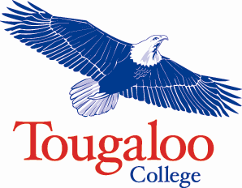

SGA APPLICATION PACKET

2023-2024

STUDENT GOVERNMENT ASSOCIATION

ELECTION PETITION

My name is and I am a candidate for for the 2023-2024 academic year. Please sign my petition. Your support is greatly appreciated.

